Algebra — Objective 4-1
Identifying Linear Functions
TEACHER ANSWER KEY (completed)
Part 1 — Identify from a Graph
1. 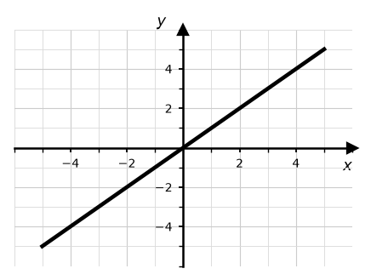  Linear / Not Linear  How do you know? straight line | 2. 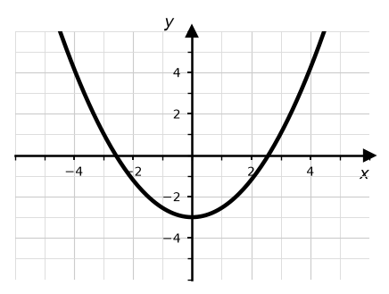  Linear / Not Linear  How do you know? curve (parabola)
3. 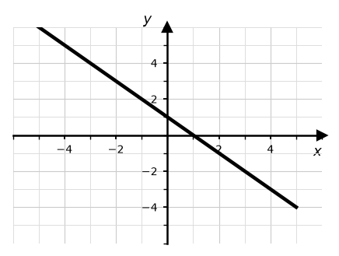  Linear / Not Linear  How do you know? straight line | 4. 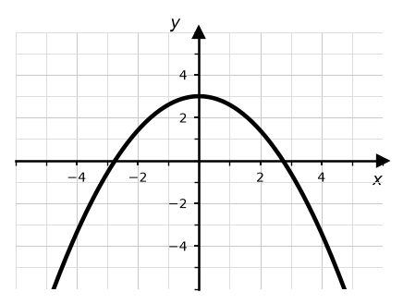  Linear / Not Linear  How do you know? curve (parabola)
Part 2 — Identify from an X-Y Table
5.  Linear / Not Linear  How do you know? y goes up +3 each step (constant rate) | 6.  Linear / Not Linear  How do you know? y-change not constant (-3, -1, +1)
  x | y
  -2 | -5
  -1 | -2
  0 | 1
  1 | 4
  x | y
  -2 | 4
  -1 | 1
  0 | 0
  1 | 1
7.  Linear / Not Linear  How do you know? y goes down -2 each step (constant rate) | 8.  Linear / Not Linear  How do you know? y-change not constant (+3, +5, +7)
  x | y
  0 | 7
  1 | 5
  2 | 3
  3 | 1
  x | y
  1 | 1
  2 | 4
  3 | 9
  4 | 16

Part 3 — Find Y and Graph
9. y = 2x + 1  Linear / Not Linear | 10. y = x²  Linear / Not Linear
   | 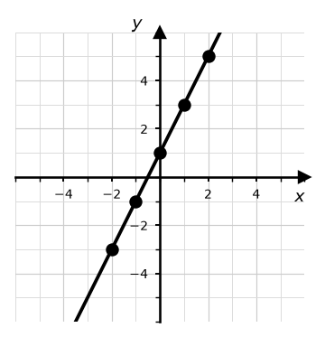
    x | y
    -2 | -3
    -1 | -1
    0 | 1
    1 | 3
    2 | 5
   | 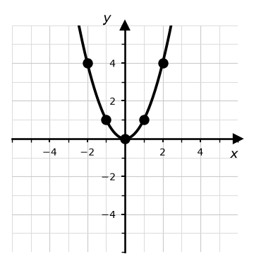
    x | y
    -2 | 4
    -1 | 1
    0 | 0
    1 | 1
    2 | 4
11. y = -x + 2  Linear / Not Linear | 12. y = x² - 3  Linear / Not Linear
   | 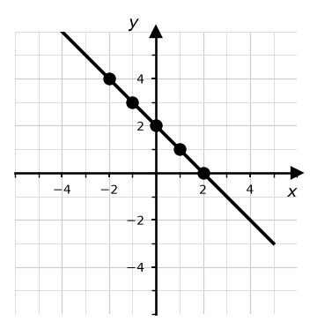
    x | y
    -2 | 4
    -1 | 3
    0 | 2
    1 | 1
    2 | 0
   | 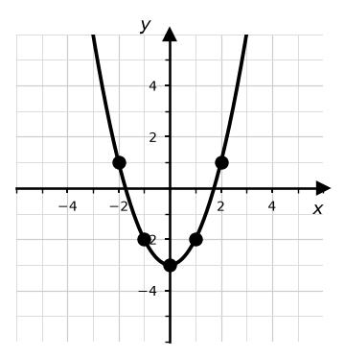
    x | y
    -2 | 1
    -1 | -2
    0 | -3
    1 | -2
    2 | 1

